UML DIAGRAMS OF FIELDSCOPE
1. USE CASE DIAGRAM
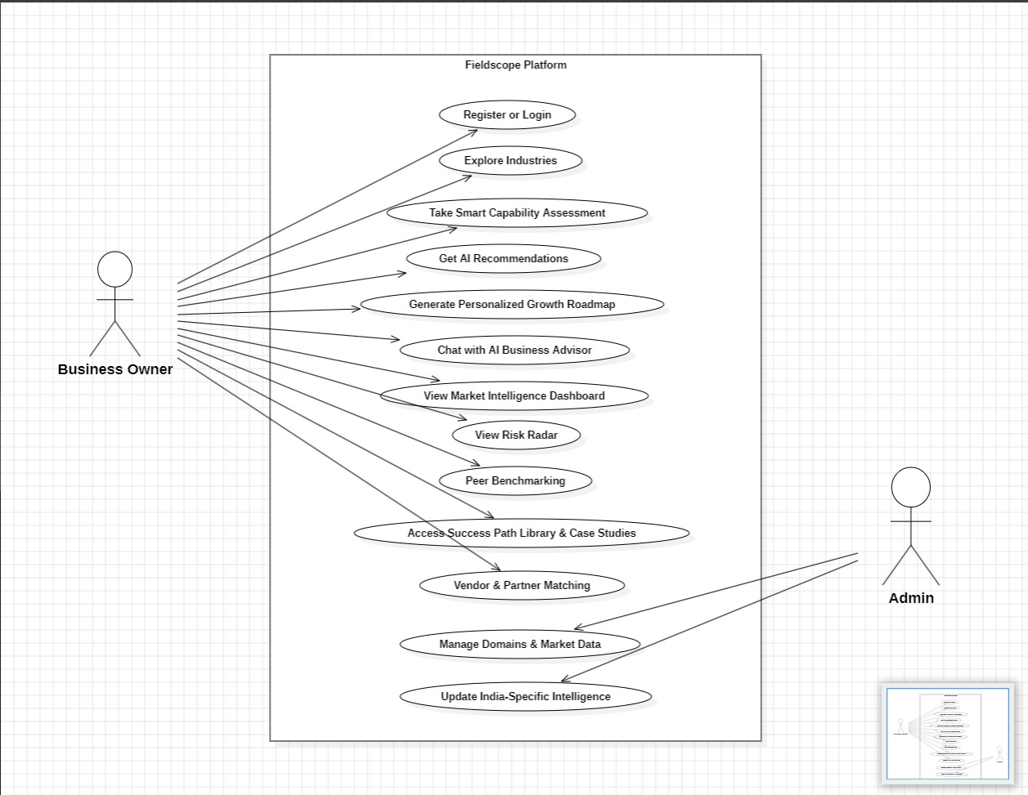

2. SEQUENCE DIAGRAM
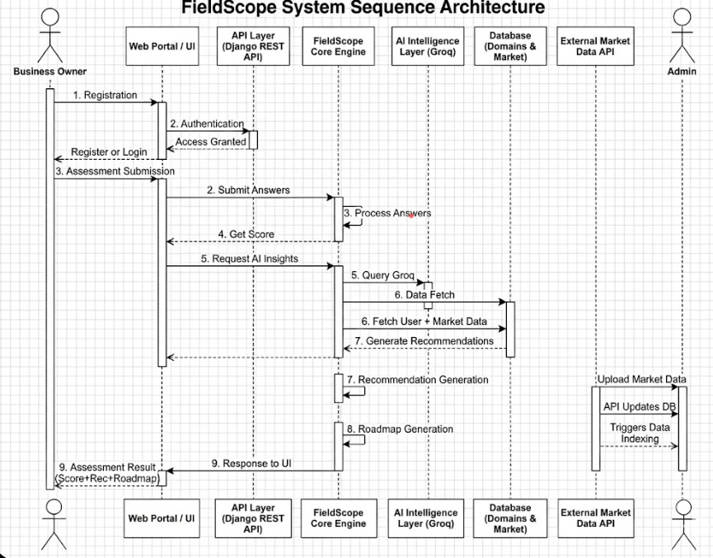
3. COMPONENT DIAGRAM
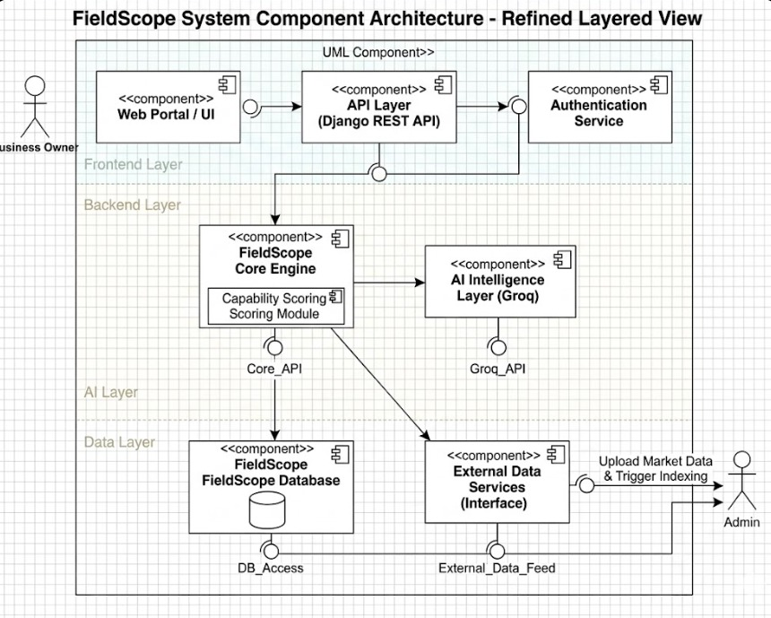

4. CLASS DIAGRAM
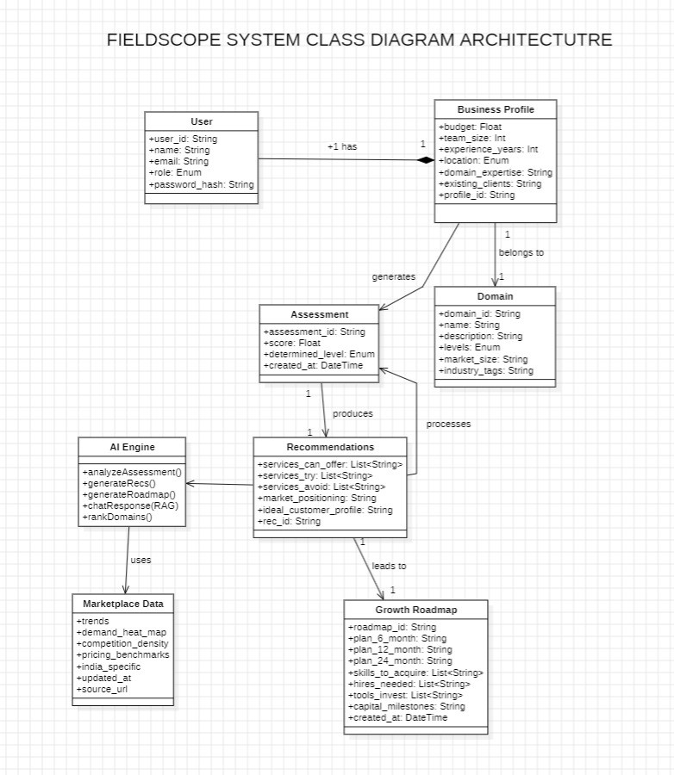

5. ACTIVITY DIAGRAM
